2.Write a program that prompts the user to input number of calls and calculate the monthly telephone bills as per the following rule:

Minimum Rs. 200 for up to 100 calls.

Plus Rs. 0.60 per call for next 50 calls.

Plus Rs. 0.50 per call for next 50 calls.

Plus Rs. 0.40 per call for any call beyond 200 calls.

def cal_telephone_bill(no_of_calls):

base_charge = 200 # Minimum charge for up to 100 calls

cost_per_call_1 = 0.60 # Cost for the next 50 calls

cost_per_call_2 = 0.50 # Cost for the next 50 calls

cost_per_call_3 = 0.40 # Cost for any call beyond 200 calls

if no_of_calls <= 100:

total_cost = base_charge

elif no_of_calls>100 and no_of_calls <= 150:

total_cost = base_charge + (no_of_calls - 100) * cost_per_call_1

elif no_of_calls>150 and no_of_calls <= 200:

total_cost = base_charge + 50 * cost_per_call_1 + (no_of_calls - 150) * cost_per_call_2

else:

total_cost = base_charge + 50 * cost_per_call_1 + 50 * cost_per_call_2 + (no_of_calls - 200) * cost_per_call_3

return total_cost

if __name__ == "__main__":

no_of_calls = int(input("Enter the number of calls: "))

monthly_bill = cal_telephone_bill(no_of_calls)

print("Monthly Telephone Bill: Rs.", monthly_bill)

for 100 calls:

Enter the number of calls: 100

Monthly Telephone Bill: Rs. 200

Enter the number of calls: 150

Monthly Telephone Bill: Rs. 230.0

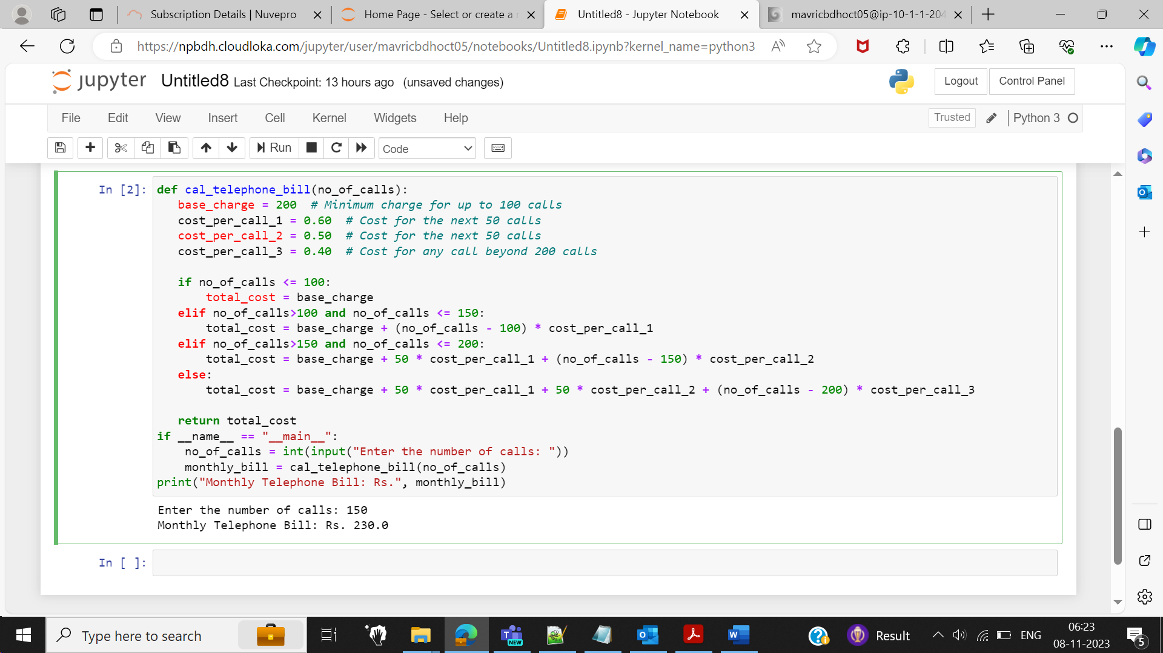

Enter the number of calls: 200

Monthly Telephone Bill: Rs. 255.0

